PDF Merger
  - v1.0.0

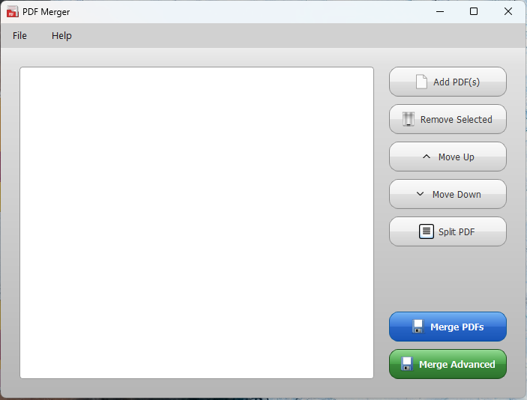
  - The PDF Merger helps you to split, re-order and merge pdf files.

How To Use
- Click on Add PDF(s) button and select the pdf files to open.
- Once opened, you use move up and down buttons to re-order the pdf files as you need. You can also use the mouse and drag pdf file to re-order.
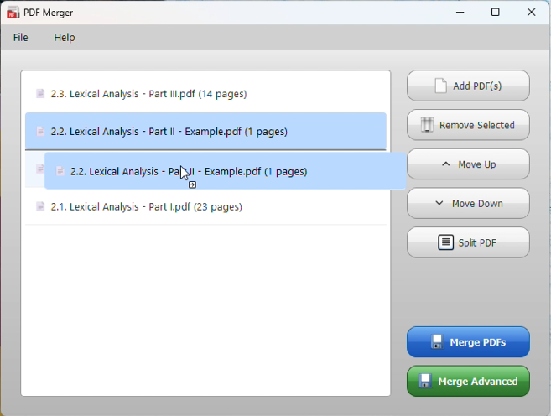
- If you want to split a pdf to parts, use the “Split PDF” button, and give the page number to split the pdf. Then click OK.
Eg: If you want to split the pdf from page 1 to 10 as one part, then 11 to 20 as another part, give 10.
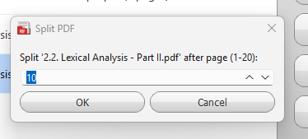
- After editing, click on Merge PDFs button to save the final pdf file.

Advance Merge Option (Experimental)
- PDF Merger supports advance merge option, which you can change the pdf layout and order multiple pages together. This option is not fully completed.

